## **curl -s** [**http://public-dns.info/nameserver/br.csv**](http://public-dns.info/nameserver/br.csv)

curl is a tool to transfer data from or to a server using protocols

-s option

It represents silent mode. It will not show progress meter or error messages. It will still output the data you ask for, potentially even to the terminal/stdout unless you redirect it.

Here Curl command is extracting the response using HTTP protocol "http://public-dns.info/nameserver/br.csv"

and using -s option will not show error messages.

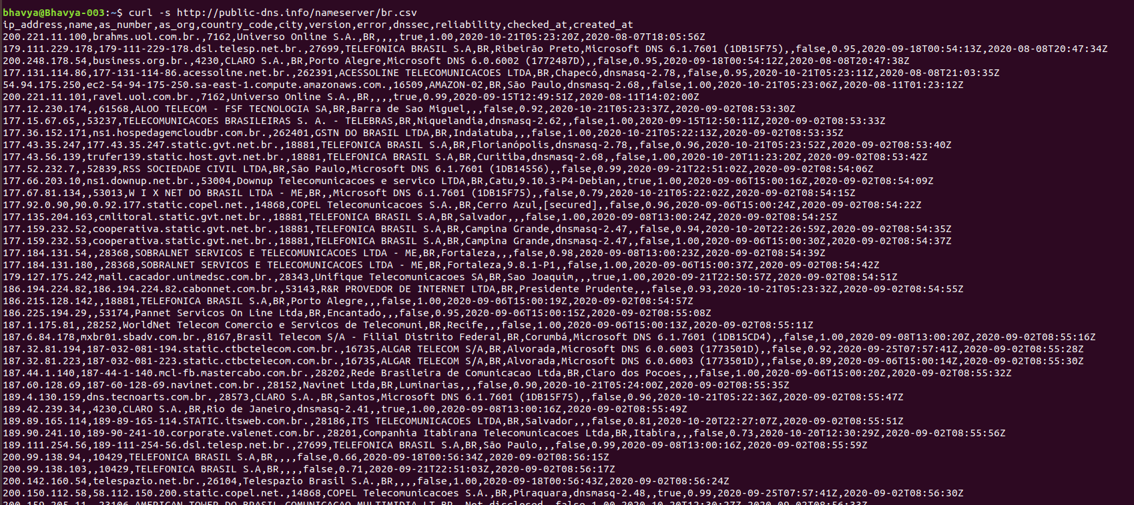

The output from curl command contains details like IP Address,name,country etc.

## **cut -d, -f1**

Cut is used for cutting out the sections from each line.

-d option is for delimiter . The above output has “ , “ as delimiter

f option is for selecting the field , f1 represents first field .

Here cut command is used to extract IP Address.

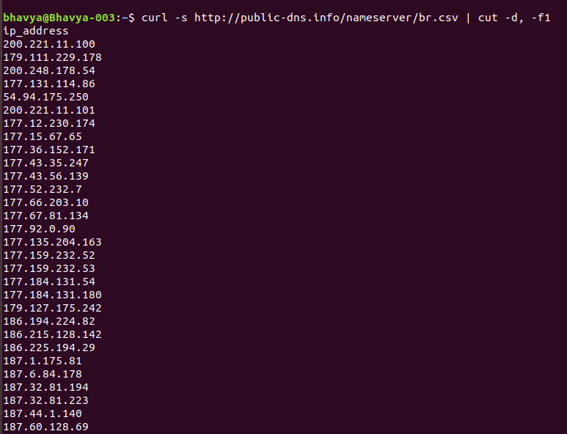

## **shuf**

shuf command shuffles the lines and outputs this to the standard output

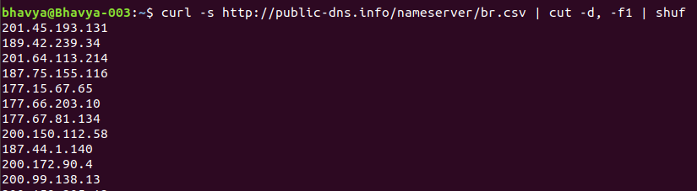

## **tail -n 50**

tail command outputs the last lines of files.

-n option for selecting number of lines to select.

Here the tail command with option '-n' 50 extracts the last 50 lines.

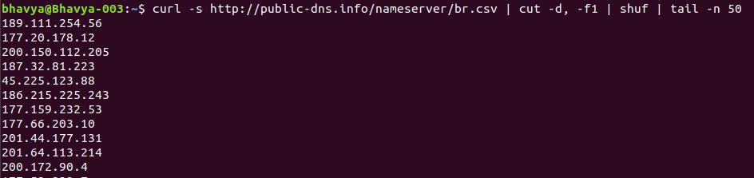

## **xargs -i timeout 1 ping -c1 -w 1 {}**

Xargs command is used to build and execute commands from standard input.

-i is used for replacing the string timeout with 1.

Ping is a command used to test the reachability of a host on an Internet Protocol network.

-c1 for only one packet request.

-w 1 specifying stop after 1 second .

{ } is used for making arguments list.

Here ,xargs command is used to pass the extracted 50 Ipaddress as arguments to ping command.

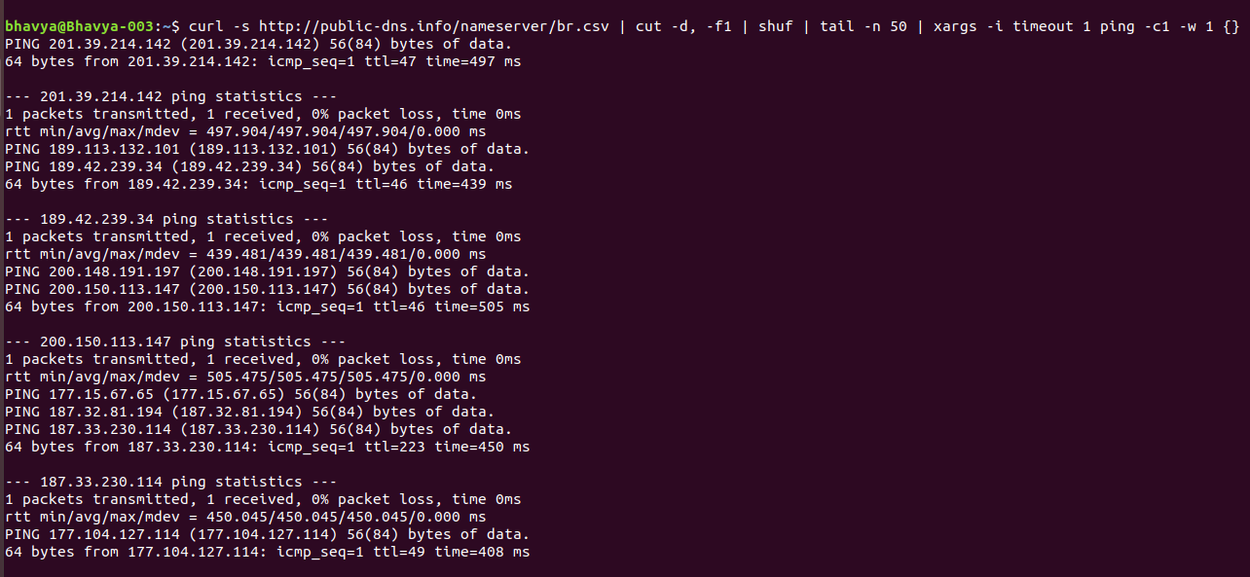

## **grep "time="**

Grep command prints the lines matching a pattern

Here grep command filters the particular lines which contains "time=".

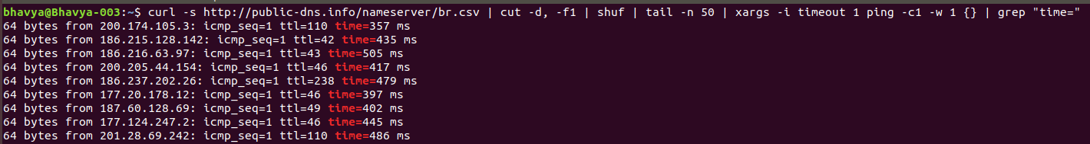

## **awk '{print substr($7, 6, length($7)) " " substr($4, 1, length($4) -1)}'**

awk is used for pattern scanning and text processing

substr function selects substring from each line.

Here,

*substr($7, 6, length($7) is extracting time*

*substr($4, 1, length($4) -1) is extracting ip address*

first argument selecting word.

Second argument denotes starting index for substring to be considered

Third argument denotes ending index.

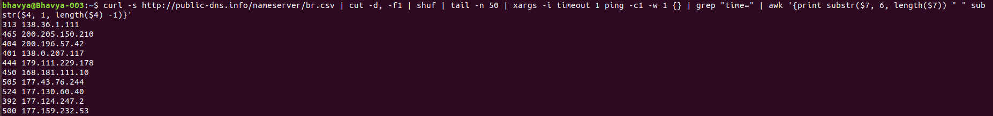

## **sort -n**

This command is used for sort lines of text files

-n option is numeric-sort

Here sort command is used to sort the lines based on the response times.

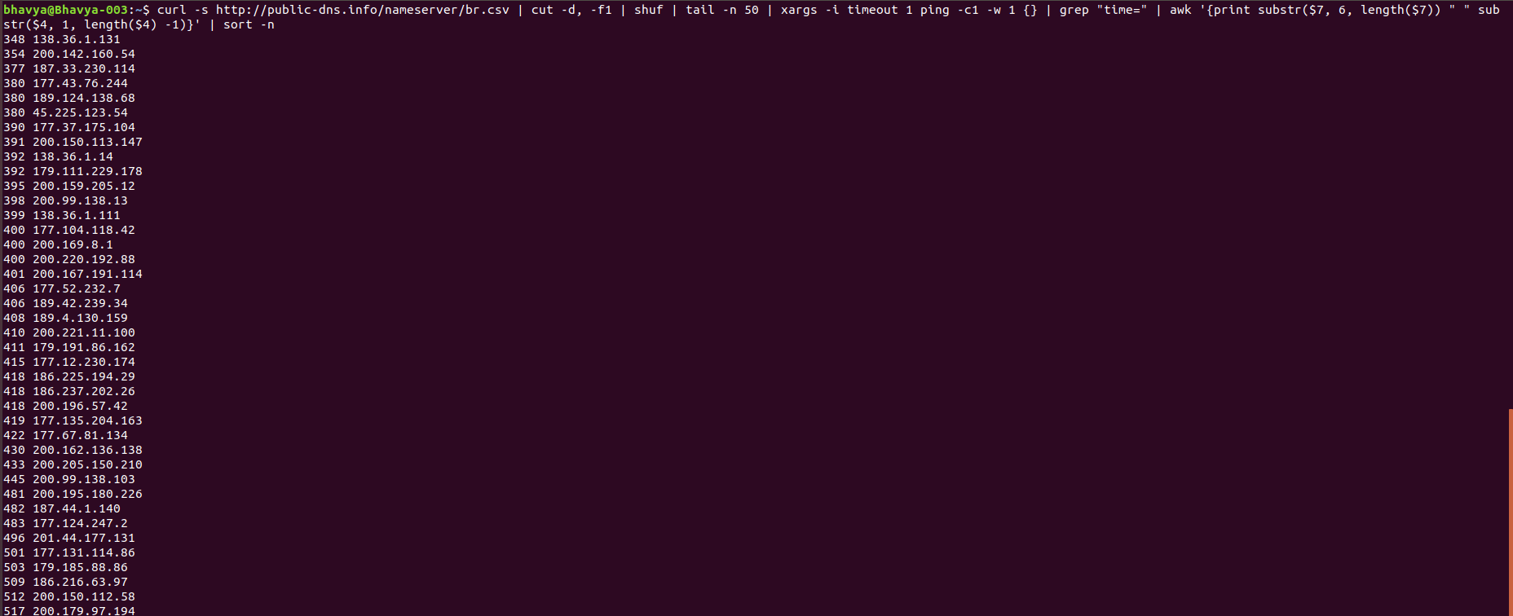

## **awk '{print $2 " " $1 "ms"}'**

in this case , awk is used to change the order of ip address first , followed by corresponding response time.

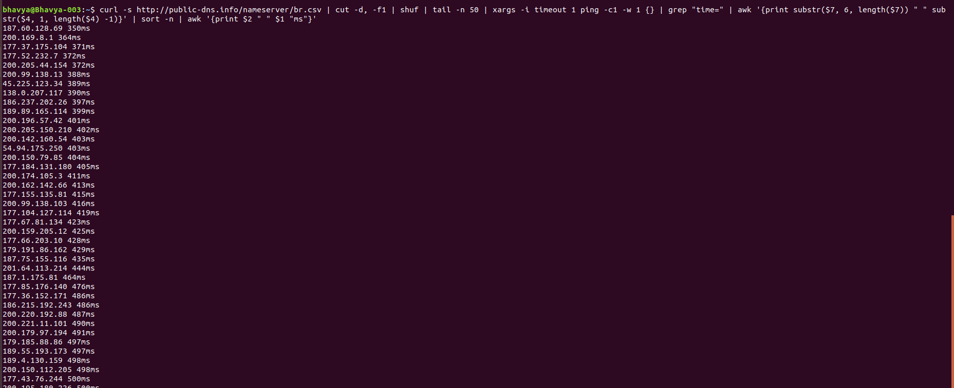

## **head -n 10**

Head command outputs the first lines of file

-n option denotes the number of lines .

Here,head command is used to output the first 10 lines of the output.

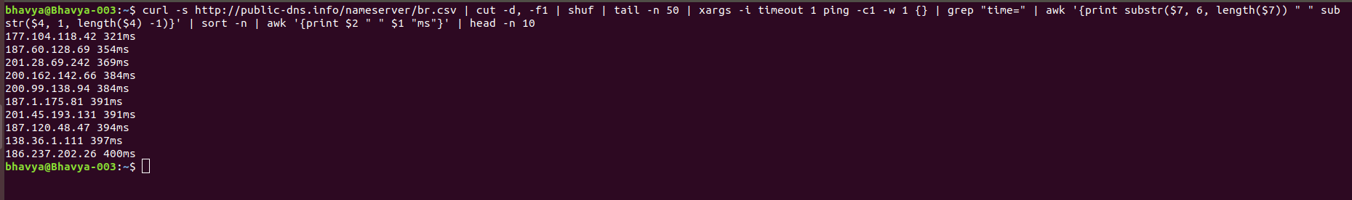

### **curl -s http://public-dns.info/nameserver/br.csv | cut -d, -f1 | shuf | tail -n 50 | xargs -i timeout 1 ping -c1 -w 1 {} | grep "time=" | awk '{print substr($7, 6, length($7)) " " substr($4, 1, length($4) -1)}' | sort -n | awk '{print $2 " " $1 "ms"}' | head -n 10**

1.The entire command selects ip addresses from [**http://public-dns.info/nameserver/br.csv**](http://public-dns.info/nameserver/br.csv)**file**

**2.** Picks random 50 from it and send the ping requests to them.

3. Based on response times the top 10 IP addresses with least response time are shown.